|  |
| --- |
| Singapore immunology Network |
| Hue Saturation Brightness workflow tutorial |
| Step by step instructions |
|  |
|  |
|  |

|  |
| --- |
|  |

Instructions are correct as of 19/12/17.

Links to websites are subject to change and not guaranteed. It is assumed that users will seek the appropriate rights, licenses or permissions to download, distribute and use them according to the relevant copyright laws from the respective owners. We do not own or endorse any of the software mentioned, and this tutorial is strictly for the purpose of illustrating the HSC workflow only.

This tutorial assumes that you have a competent 64-bit computer running Windows 10, and have the necessary administrator rights. For the purposes of this tutorial, it also assumes that the computer has a fully licensed version of Imaris (version 8.4.2), FlowJo VX (version 10.4.1) and Microsoft Excel (2010). In many cases, older or newer versions of the software should have the same functionality as described, but may not necessarily be accessed in the same manner described.

For clarity, in this tutorial, full filepaths are always given assuming a user account named “Lenovo” (C:\Users\Lenovo\) on the C drive. Users should substitute the file paths accordingly.

Table of Contents

1 Getting Started 3

1.1 Initial Set Up of software environment for Windows 10, FIJI, WinPython 3.5.1.3 and WinPython 2.7.10.2. 3

1.2 Initial Set Up of software environment for HSC scripts 4

1.3 Initial Set up of software environment for running Python on Imaris 8

1.4 Loading HSC LUTs into FIJI and Imaris 9

1.5 Test Data 9

2 Using the Hue-Saturation-Brightness surface creation (HSC) workflow 12

2.1 Rename TIF files to standard format 12

2.2 Reduce number of channels to 3 by merging channels (Optional) 13

2.3 Generate Hue, Saturation and Brightness channels 14

2.4 Surface creation using the Brightness channel in Imaris and statistics extraction. 16

2.5 Saving out Surface Statistics 21

2.6 Aggregate statistics into single CSV file and Gating in FlowJo 22

2.7 Backgating in Imaris (Version 8.4.2) 29

3 Spectral Compensation (optional) 32

3.1 Compensation using FlowJo 32

3.2 Correction of original images 39

# Getting Started

## Initial Set Up of software environment for Windows 10, FIJI, WinPython 3.5.1.3 and WinPython 2.7.10.2.

1. Press the Windows button and immediately type “Show hidden files and folders”. Click on the corresponding search result to display the File Explorer Options window. Ensure that the option for Hide extensions for known file types is left unchecked. Click OK to save the settings.

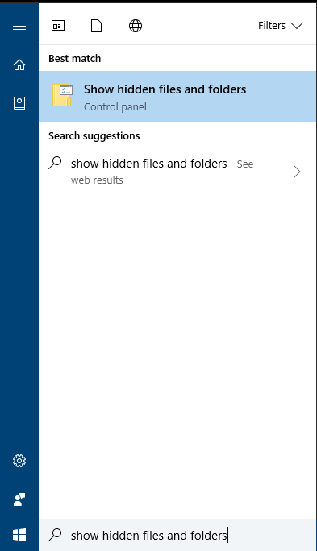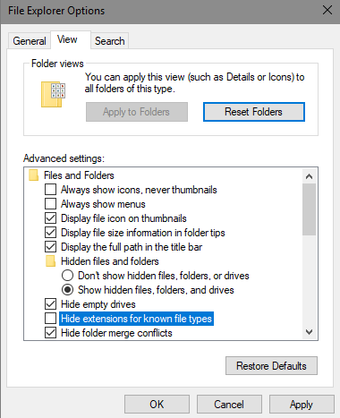

Unhiding extensions for known file types

▲Critical step

This ensures that you are always able to recognize the file type (e.g. .py, .txt, .tif etc.) of the file that you are working on.

1. On the desktop (C:\Users\Lenovo\Desktop), create a folder called Software.
2. Create a subfolder called FIJI in the folder Software.
3. Download FIJI is Just ImageJ (FIJI) from the source website (<https://fiji.sc/> ). Unzip the contents of the FIJI download into this folder.
4. Find the file C:\Users\Lenovo\Desktop\Software\FIJI\fiji-win64\Fiji.app\ImageJ-win64.exe. Select the file, right click, and choose Send to > Desktop (create shortcut). This creates a shortcut on the desktop that allows you to launch FIJI conveniently.
5. Create another subfolder called WinPython35 in the folder Software.
6. Download the 64 bit WinPython (version 3.5.1.3) from the source website (<https://sourceforge.net/projects/winpython/files/WinPython_3.5/3.5.1.3/>). Do not download the “Zero” versions. Run the installer and follow the instructions. When prompted for the install location, browse to the C:\Users\Lenovo\Desktop\Software\WinPython35\ folder.

**►Troubleshooting**

If you are running Windows 7 or 8 instead of Windows 10, note that you might also need to install Microsoft Visual C++ packages in order to get WinPython to work. See <https://github.com/winpython/winpython/wiki/Installation> for details (e.g. Microsoft Visual C++ Redistributable for Visual Studio 2015 is required for WinPython 3.5.1.3. Use your search engine to find the required downloads from the official websites).

1. Go to C:\Users\Lenovo\Desktop\Software\WinPython35\WinPython-64bit-3.5.1.3\ python-3.5.1.amd64\ and look for the file python.exe.

▲Critical step

This prevents a critical bug in Windows systems that may otherwise occur when working with multiple versions of WinPython.

1. Create another subfolder called WinPython27 in the folder Software.
2. Download the 64 bit WinPython (version 2.7.10.2) from the source website (<https://sourceforge.net/projects/winpython/files/WinPython_2.7/2.7.10.2/>). Run the installer and follow the instructions. When prompted for the install location, browse to the C:\Users\Lenovo\Desktop\Software\WinPython27\ folder.

## Initial Set Up of software environment for HSC scripts

1. Create a subfolder called HSC in the folder Software.
2. Download the HSC scripts and look up tables from the supplementary information section in the manuscript. Unzip the contents into this folder. You should now have two new folders named Data and Scripts directly in the HSC folder.
3. In Windows, locate the first script C:\Users\Lenovo\Desktop\Software\HSC\Scripts\P01_Rename tif files into standard format.py. To let Windows associate .py files with WinPython 3.5.1.3, right-click the file and select Open with > Look for another app on this PC, and browse to C:\Users\Lenovo\Desktop\Software\WinPython35\WinPython-64bit-3.5.1.3\ python-3.5.1.amd64\python.exe to run the application. Ensure that the option Always use this app to open .py files is **checked**. Click OK.

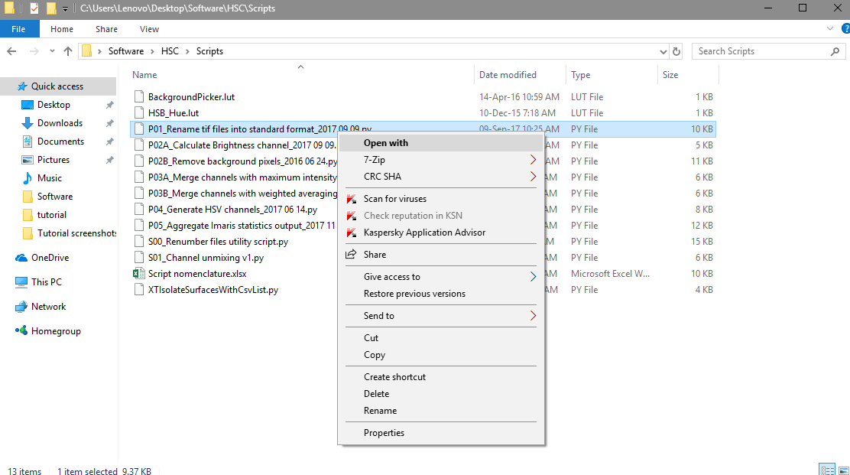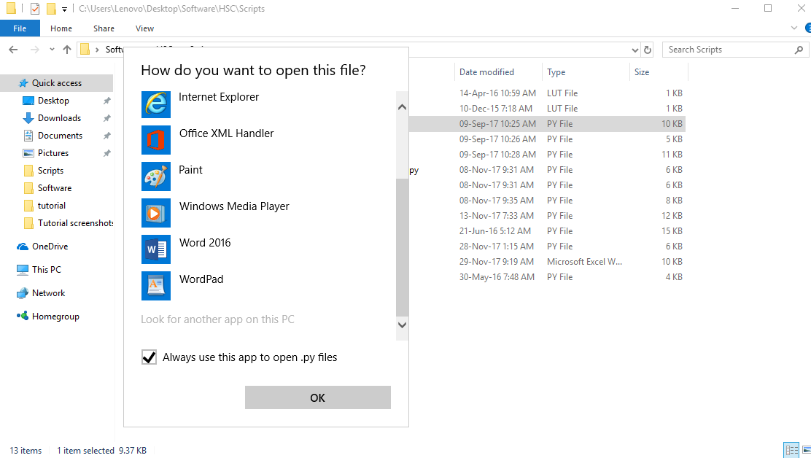

Initial steps for associating .py files with python.exe

Since we are not yet doing anything, press OK when the program message appears, but then click Cancel when the program asks for the folder to process. Some error messages should pop up in a new command window, but you can safely ignore and close them.

□Explanatory note

You should now be able to directly run .py scripts by double clicking on the file.

## Initial Set up of software environment for running Python on Imaris

1. Open the Imaris software. To set up Python 2.7 for Imaris XT, go toFile **>** Preferences **>** CustomTools, click Browse under Python 2.7 Application and browse to *C:/Users/Lenovo/Desktop/Software/WinPython27/WinPython-64bit-2.7.10.2/python-2.7.10.amd64/*python.exe as illustrated in the screenshot below.

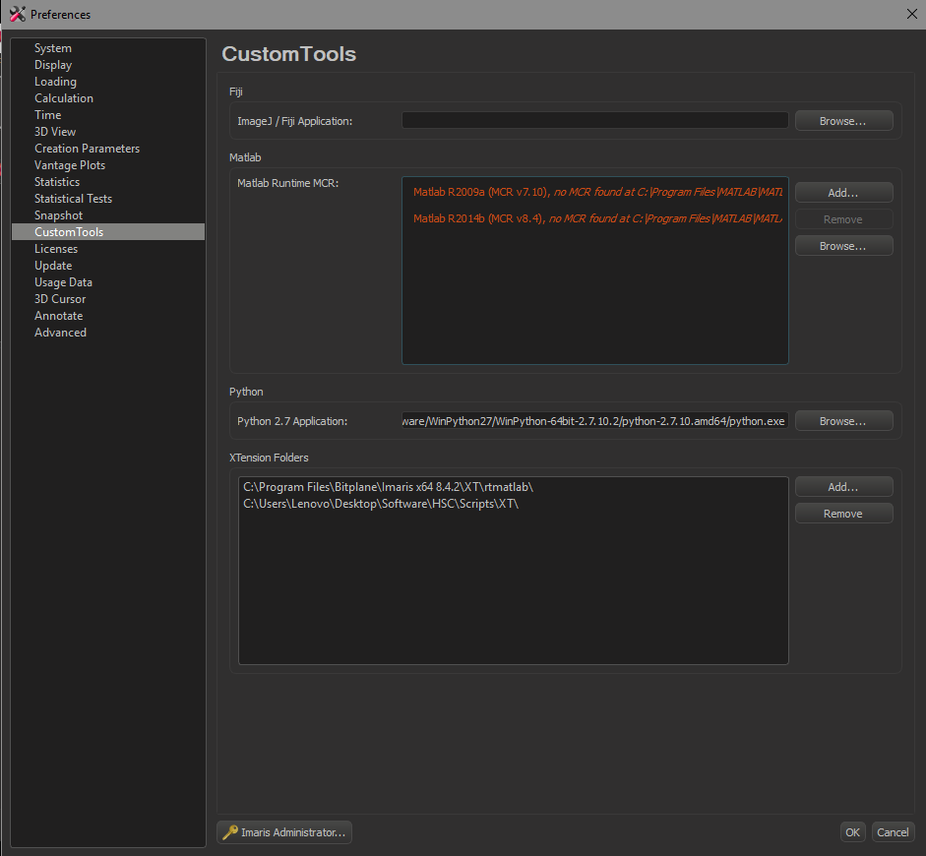

Setting up WinPython 2.7.10.2 to work with Imaris XT

1. Under the XTension Folders tab, click Add…, and browse to C:\Users\Lenovo\Desktop\Software\HSC\Scripts\XT. Click Select Folder. Click OK to close the settings window. Close the Imaris window and restart the software. Now, you should be able to see Image Processing > XTIsolateSurfacesWithCsvList appearing as an option.

►Troubleshooting

Click on Image Processing > XTIsolateSurfacesWithCsvList to test if the script is working. You should see a command window with a message asking you to create some surfaces in the Surpass scene first. However, if you do not see this screen, but instead get a command window that flashes briefly and then immediately disappears, the XT is not working. Try changing the filepath in **Step 18** to C:/Users/Lenovo/Desktop/Software/WinPython27/WinPython-64bit-2.7.10.2/ python.exe instead. Contact your software manufacturer if this still does not work.

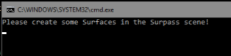

Pop up command window showing WinPython script working with Imaris XT

## Loading HSC LUTs into FIJI and Imaris

In order to visualize the hue of surfaces and cells, a customized look up table (LUT) for the hue channel has been created for FIJI and Imaris.

1. Find the file C:\Users\Lenovo\Desktop\Software\HSC\Scripts\HSB_Hue.lut, and copy and paste the file into C:\Users\Lenovo\Desktop\Software\FIJI\fiji-win64\FIJI.app\luts\. Do the same for BackgroundPicker.lut. FIJI will automatically detect the LUT the next time it starts up.
2. Find the file C:\Users\Lenovo\Desktop\Software\HSC\Scripts\HSB.pal. Go to the folder where Imaris is installed, (e.g. C:\Program Files\Bitplane\Imaris x64 8.4.2\colorTables\) and copy and paste the file in. Imaris will automatically detect the LUT the next time it starts up.

## Test Data

1. Create a new folder called Data on the desktop (C:\Users\Lenovo\Desktop\Data). Copy and paste the raw data file (Olympus format) C:\Users\Lenovo\Desktop\Software\HSC\Data\Testdata.oib into this new folder.
2. Start FIJI, and go to File > Open. Select the filepath for C:\Users\Lenovo\Desktop\Data\Testdata.oib and click OK. Use the default import settings and click OK.

□Explanatory note

By default, FIJI uses the Bio-Formats Importer (under Plugins > Bio-Formats > Bio-Formats Importer) to read in data from most major microscope manufacturers.

□Explanatory note

With an image file open and selected, by mousing over the image, the FIJI main window will display the specific intensity value of the pixel where the mouse is pointing to, as well as other useful information about the image. An image is simply a grid of numbers (representing intensities), where the computer uses a look-up table (LUT) to map each number to a specified color to display on screen.

1. Go to Image > Type and select 32bit.

□Explanatory note

This converts the images from 16 bit to 32 bit for compatibility with some scripts.

1. Go to File > Save As > Image Sequence… and the following dialog box should pop up.

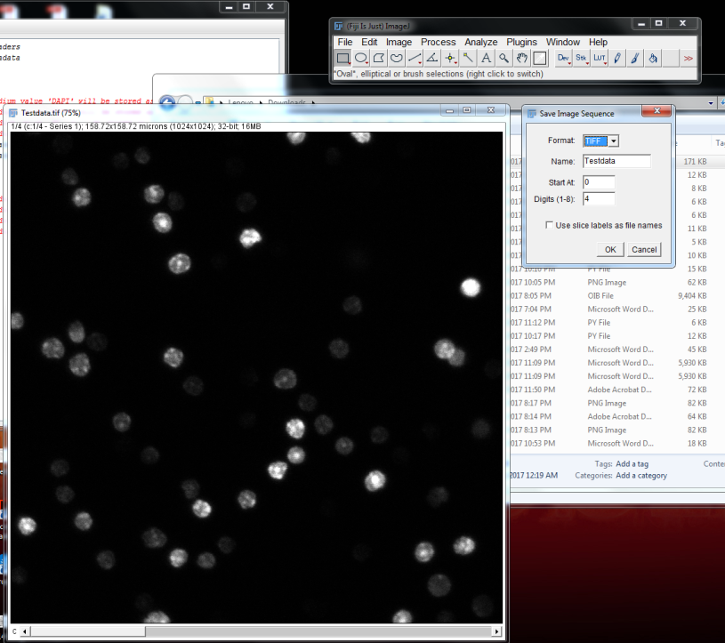

Save Image Sequence Dialog box in FIJI

1. Select the format as “TIFF” and key in “Testdata_c” (i.e. without the literals/ inverted commas) under the Name category and click OK.

□Explanatory note

For multidimensional data (i.e. hyperstack), FIJI typically names them in the following format: e.g. XXX_t0001_z0005_c0009.tif, and no further adjustments are normally necessary. However, in the case of a single dimensional data, its default behaviour is to only include the numbering after the prefix, e.g. XXX0006.tif. To disambiguate whether the number represents channel number (c), z slice position (z), or time index (t), we had to manually include “_c” in the filenames to inform the subsequent script that they represent channel numbers in this case.

▲Critical step

It is important that the “c” be keyed in lower case and not as the capital letter “C”.

1. Create a subfolder TIFF under the Data folder, and save the TIFF images there. 4 TIFF images should be now saved under the TIFF folder, labelled Testdata_c0000.tif to Testdata_c0003.tif.
2. Only the files Testdata_c0000.tif to Testdata_c0002.tif contain fluorescent microscopy data. Delete Testdata_c0003.tif.

□Explanatory note

Image Channel Information:

Testdata_c0000: DAPI

Testdata_c0001: CFSE

Testdata_c0002: Propidium Iodide

Testdata_c0003: Transmitted light (to be deleted)

# Using the Hue-Saturation-Brightness surface creation (HSC) workflow

### Rename TIF files to standard format

1. Go to C:\Users\Lenovo\Desktop\Software\HSC\Scripts\, run the script named P01_Rename tif files into standard format.py. The script should start, and the following dialog box will appear:

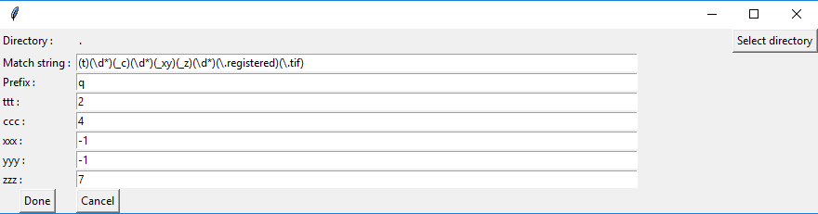

Graphical User Interface for P01

1. Click Select directory, and select the file path for C:\Users\Lenovo\Desktop\Data\TIFF\. The script should complete running, and the following dialog box will appear:

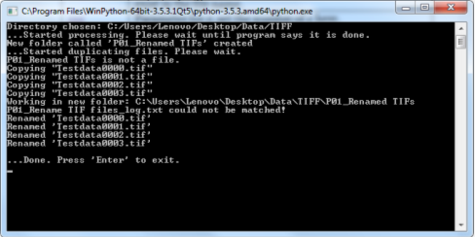

Command window after P01 has completed running

1. Close the command window.
2. A new folder P01_Renamed TIFs is now saved as a subfolder under the earlier selected path. A log file P01_Rename TIF files_log.txt and three renamed TIFF files in the format q_t0000_c00_x000_y000_z0000.tif to q_t0000_c02_x000_y000_z0000.tif are found in this folder.

□Explanatory note

The script renames the TIFF files it finds in the folder that matches a set of predefined nomenclature patterns. In this case, the script looked for the pattern “XXX_c0000.tif” and recognized that the numbers after “_c” represent the channel numbers. The TIFF files need to be renamed into a specific convention so that subsequent scripts can correctly identify the position of each image. The script is designed to read in multiple types of filenames from FIJI and Imaris, and can also be modified to rename TIFF files with custom nomenclature from other sources. Refer to the manual for details.

### Reduce number of channels to 3 by merging channels (Optional)

In our current test dataset, there is no need to merge channels, since we only have 3 channels - each be designated as one of the three RGB input channels. However, if you are using an image with 4 or more channels, you may need to merge channels. We have provided a script that calculates the maximum intensity projection of the input channels. We provide the instructions in this section as part of the full HSC workflow, but in this tutorial, we will not be using them.

1. Run the script P02_Calculate max intensity channel.py.

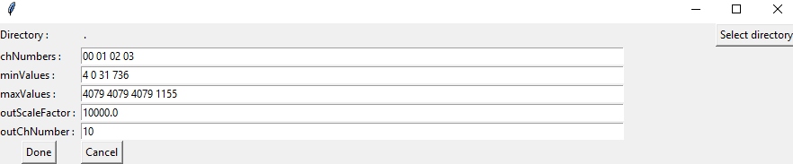

Graphical User Interface for P02

1. Key in the appropriate input channel numbers for merging (as a list) in the parameter inChNumbers and designate the output channel name with outChNumber.

**▲Critical step**

The number of each channel can be separated using a space or a comma.

1. Input the minimum values of each channel in the parameter minValues and the maximum values of each channel in the parameter maxValues. This allows each channel to be scaled according to its dynamic range. The user can decide on the values to input manually or they can obtain these values by opening the images in FIJI.

Pressing Ctrl+Shift+C in FIJI opens the brightness and contrast panel, and the program automatically scales each channel to its minimum and maximum values when the Auto button is pressed.

1. Click Select directory and choose the folder that contains the TIFF files (usually P01) and press Done.

**▲Critical step**

New files with the channel number outChNumber will be created in the same folder as the input path. Ensure that they do not have the same channel number as any other image files within the folder as they will be overwritten without warning.

### Generate Hue, Saturation and Brightness channels

1. Run the script P03_Generate HSB channels.py. The following screenshot should show up:

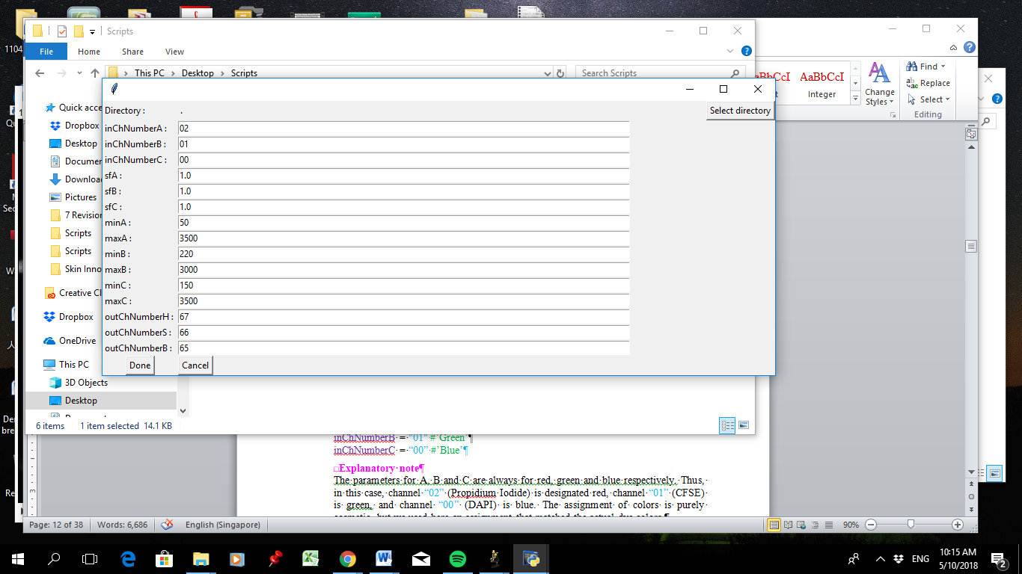

Graphical User Interface for P03

1. Key in the following values for the input channel numbers:

inChNumberA = "02" #’Red’

inChNumberB = "01" #’Green’

inChNumberC = “00” #’Blue’

□Explanatory note

The parameters for A, B and C are always for red, green and blue respectively. Thus, in this case, channel “02” (Propidium Iodide) is designated red, channel “01” (CFSE) is green, and channel “00” (DAPI) is blue. The assignment of colors is purely cosmetic, but we used here an assignment that matched the actual dye colors.

1. Set the scale factors for the input channels using the following values:

sfA = 1.0

sfB = 1.0

sfC = 1.0

1. Set the minimum and maximum values for the input channels using the following values:

minA = 50

maxA = 3500

minB = 220

maxB = 3000

minC = 150

maxC = 3500

1. Keep the output channel numbers as follows, and save the script before closing it.

outChNumberH = “67” #Hue

outChNumberS = “66” #Saturation

outChNumberB = “65” #Brightness

1. Click Select directory and choose the file path for C:\Users\Lenovo\Desktop\Data\TIFF\P01_Renamed TIFs.
2. The following command window should appear. Close the command window.

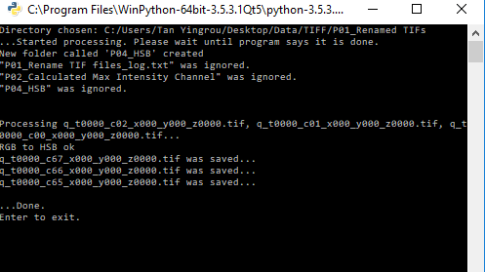

Output command window from script P03

1. A new subfolder P03_HSB containing the log file and TIFF files of the Hue (“c67”), Saturation (“c66”) and Brightness (“c65”) channels is now saved under the file path C:\Users\Lenovo\Desktop\Data\TIFF\P01_Renamed TIFs\P03_HSB\.

□Explanatory note

For a two-channel image, for instance a GFP and YFP image, the ‘blue’ channel (Channel C) uses the YFP channel as a placeholder, and large numbers can be used as the minimum and maximum values to ensure that the input from this channel is negligible. The parameters listed below are derived from a sample 2 channel image.

inChNumberA = “00” #Red - YFP

inChNumberB = “03” #Green - GFP

inChNumberC = “00” #Blue – YFP (Placeholder channel)

sfA = 1.0

sfB = 1.0

sfC = 1.0

minA = 250

maxA = 800

minB = 200

maxB = 1500

minC = 10000

maxC = 10010

outChNumberH = “67”

outChNumberS = “66”

outChNumberB = “65”

### Surface creation using the Brightness channel in Imaris and statistics extraction.

1. Start Imaris, and open the **original** TIFF files from C:\Users\Lenovo\Desktop\Data\TIFF\P01_Renamed TIFs\.

►Troubleshooting

In later versions of Imaris with Arena, you may need to toggle to Surfaces mode first before you can access the Open button.

1. Press Ctrl + I to open the Image Properties panel of Imaris. Key in the following parameters for the voxel sizes, and press OK when done:

X: 0.155

Y: 0.155

Z: 1

**▲Critical step**

It is important to key in the right values for the voxel size. If not, it will be necessary to regenerate the surface again in order to get the correct length scale.

1. If not already open, press Ctrl + D to toggle the Display Adjustment panel of Imaris. Set the following minimum and maximum values for the channels:

Channel 1: Min: 150 Max: 3500

Channel 2: Min: 220 Max: 3000

Channel 3: Min: 50 Max: 3500

□Explanatory note

In the Base Color LUT, pixels with values smaller than or equal to the Min value is set as black (i.e. invisible), and pixels with values greater than or equal to the Max value is rendered in the maximum possible brightness (i.e. saturation – brighter pixels look no different from dimmer pixels beyond this point). By default, pixels with values in between are linearly interpolated and rendered with the corresponding hue intensity if Gamma is set as 1.0.

1. Press Ctrl + I again. Go to Channels panel, and in the Base Color tab, set the channel colors accordingly, and press OK when done:

Channel 1: Red: 0.000 Green: 0.000 Blue: 1.000 (i.e. pure blue)

Channel 2: Red: 0.000 Green: 1.000 Blue: 0.000 (i.e. pure green)

Channel 3: Red: 1.000 Green: 0.000 Blue: 0.000 (i.e. pure red)

□Explanatory note

This sets the individual grayscale channels to utilize the base blue, green and red LUTs respectively. Thus, Channel 1 appears blue, Channel 2 green, and Channel 3 red. You can also directly access the Base Color tab by clicking on the channel name in the Display Adjustment tab.

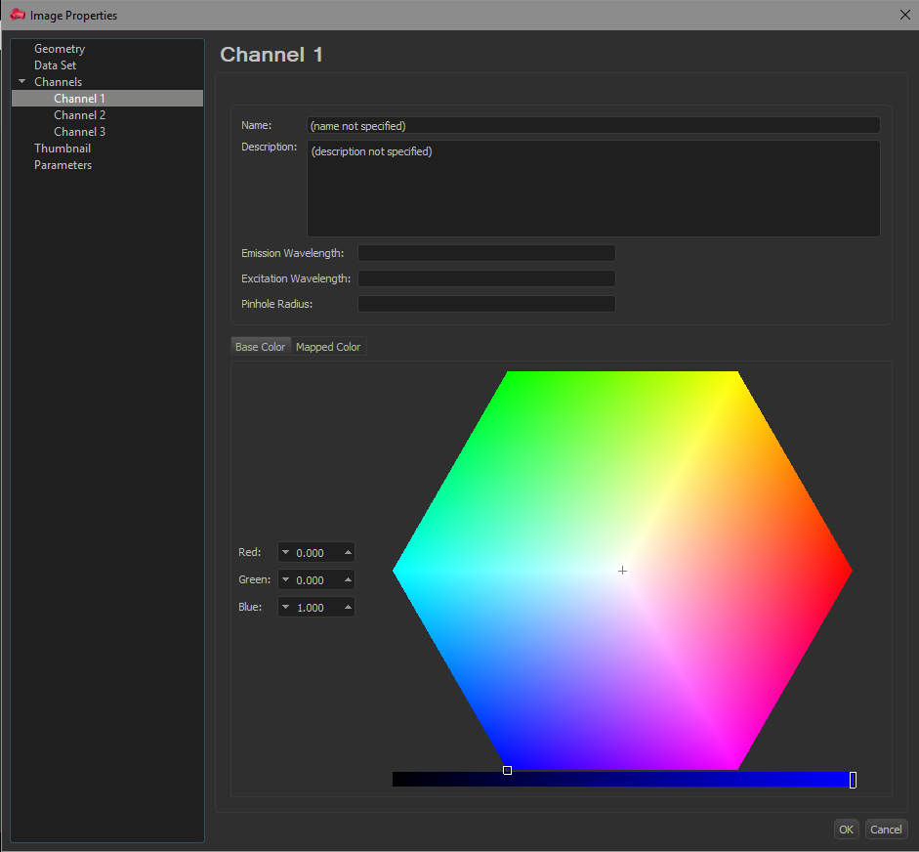

Channel color representation selection window of Imaris

□Explanatory note

Take note of how Imaris represents colors using the **HSB model** in their color picker tool. If you key in a combination of values in the RGB model on the left, the specific color will be represented by the location of the small white square (in the hexagon) and rectangle (in the linear bar below). The six cardinal points of the hexagon represent the ‘pure’ hues (red, magenta, blue, cyan, green and yellow), and the angle of the white square relative to the origin indicates the corresponding **Hue** of the RGB combination. The relative distance from the origin (which is pure white) indicates its **Saturation** (i.e. how ‘diluted’ by white the RGB combination is). Finally, its position on the linear bar below indicates its **Brightness** (i.e. how ‘dim’ the color appears – note how the color bar goes to pure black when brightness is set to zero no matter what hue you set in the hexagon). If you are still confused by the HSB model, experiment with the color picker to get a better understanding of how it works.

1. Go to Edit > Add channels, and add the transformed Hue, Saturation and Brightness channels from C:\Users\Lenovo\Desktop\Data\TIFF\P01_Renamed TIFs\P03_HSB\. The Brightness channel now appears as Channel 4, the Saturation channel is Channel 5 and the Hue channel is Channel 6.
2. Set Channel 4 as white using the similar procedure from **step 62** (Red: 1.000 Green: 1.000 Blue: 1.000). On the Display Adjustment tab, hide the rest of the channels except for Channel 4, by unchecking the small check boxes beside the channel names.
3. In the Surpass tree, click Add new surface and use the following settings and go to the next step:

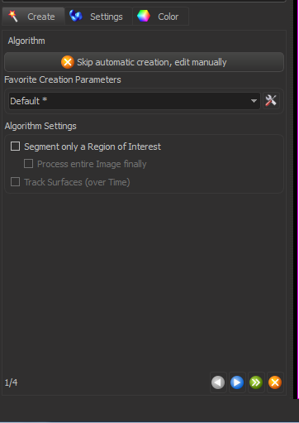

Surface creation step 1

1. Use the following settings and go to the next step:

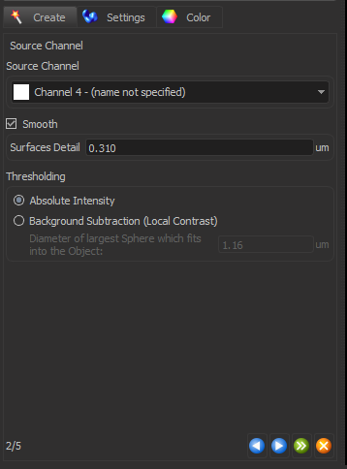

Surface creation step 2

1. Use the following settings and go to the next step:

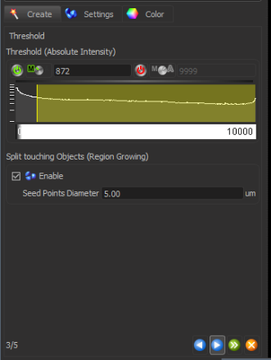

Surface creation step 3

1. Set the Quality value as 381, and the following screen should appear:

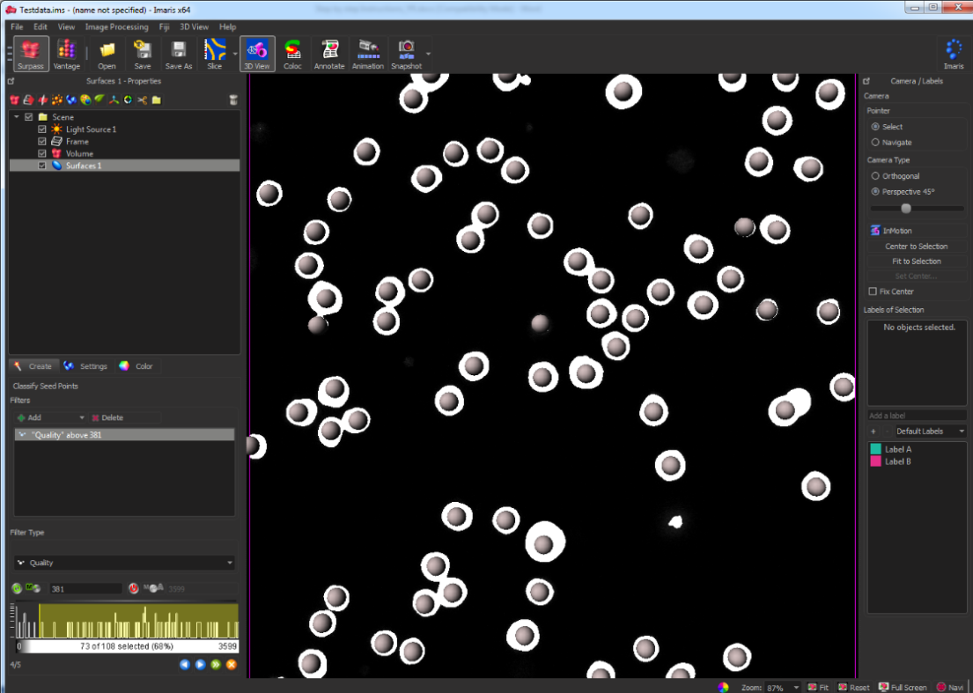

Surface creation step 4

1. Go to the next step, and set the Filter by voxel value as 10.
2. Click Finish.
3. To render the surfaces in their native hue, select Surfaces 1 in the Surpass tree. Look for the Color tab, then go to Color Type box and select Statistics Coded. Under the Statistics Type drop-down option box, select Intensity Median Ch=6. Under Colormap, select the HSB look up table. Under Colormap Range set the minimum (Min:) as 0 and the maximum (Max:) as 40 000.

□Explanatory note

The surfaces are now rendered using the custom LUT that we earlier provided (HSB.pal). When fully stretched from 0 to 40,000, the LUT maps the Hue channel (Channel 6) information to its expected color. The hue of the surfaces should reflect the actual colors of the cells when the Blue, Green and Red channels are simultaneously turned on (i.e. Channels 1, 2 and 3).

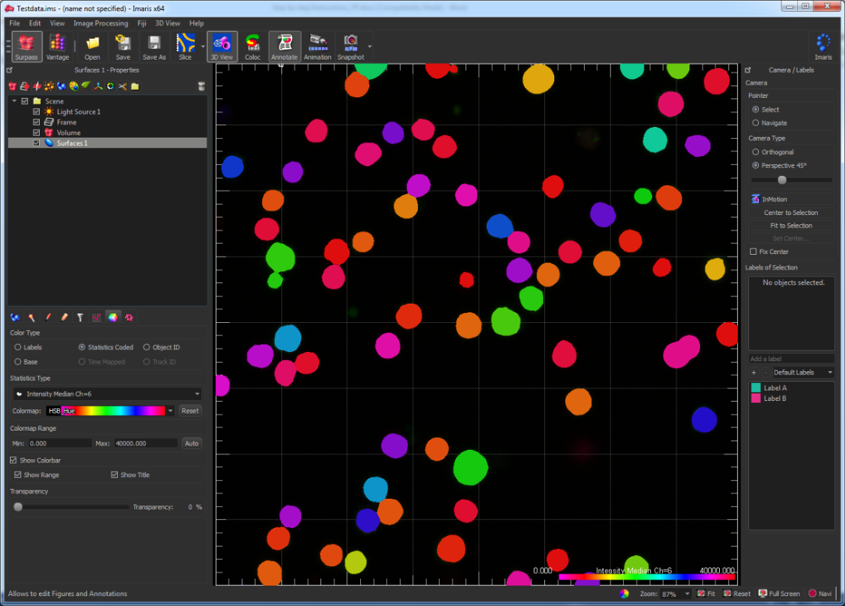

Surfaces rendered in their native hue

1. Save the Imaris file as Testdata.ims in C:\Users\Lenovo\Desktop\Data\ (click File > Save As…).

►Troubleshooting

In later versions of Imaris with Arena, you may need to click File > Export instead.

### Saving out Surface Statistics

1. Go to File > Preferences > Statistics. Select the Surfaces tab and click on the checkbox until a tick is seen, as shown below.

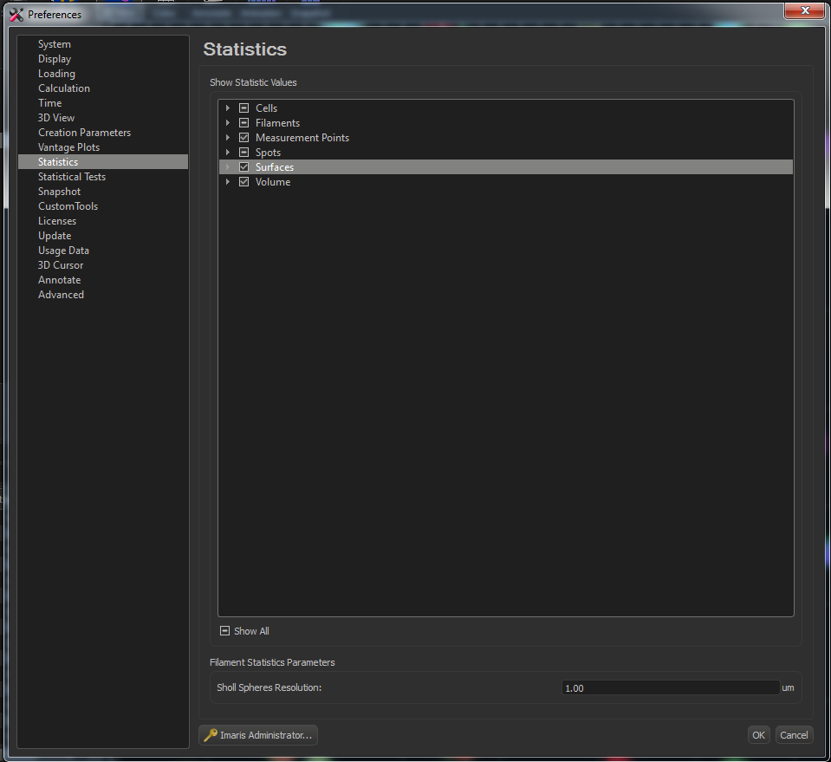

Selection of types of statistics to include for Surfaces

□Explanatory note

This step selects what kind of statistics is included to be calculated by Imaris. When the checkbox displays a tick, it means that all possible statistics will be included. If you wish, you can modify this by clicking on the small triangle on the left, and choosing only the relevant statistics you would like Imaris to report.

1. Select the surface (Surfaces 1), go to the Statistics tab, and select Detailed. Click on the button for Export All Statistics to File and save the statistics in a comma separated values (CSV) format into the following folder: C:\Users\Lenovo\Desktop\Data\ with the name “Testdata”. A subfolder Testdata_Statistics will now be generated in the selected folder containing multiple CSV files for each statistic. Close Imaris.

**▲Critical step**

Avoid using any underscores in the name used for saving the statistics (excluding the ones automatically generated by Imaris itself) to prevent errors from occurring downstream when aggregating the statistics into a single CSV file.

### Aggregate statistics into single CSV file and Gating in FlowJo

1. Run the script labelled P04_Aggregate Imaris statistics output.py. The following window should appear:

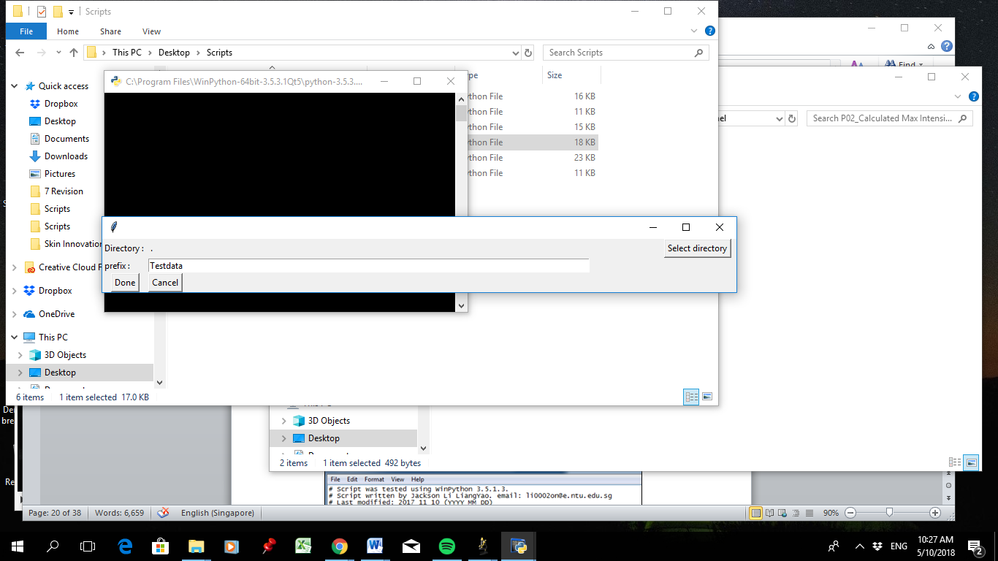

Graphical User Interface for P04

Set the following, save and close the file:

prefix = “Testdata”

□Explanatory note

The variable prefix allows the user to customise the label for the file.

1. Click Select directory, and select the filepath C:\Users\Lenovo\Desktop\Data\Testdata_statistics\ which contains the exported CSV files. Click Done. The script will consolidate the statistics from the individual files into a single CSV file.

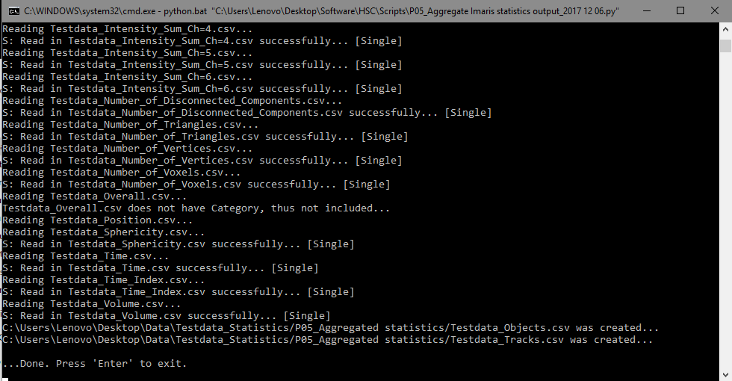

Command window after P05 has completed running

1. A new subfolder, P05_Aggregated statistics, containing 2 CSV files, Testdata_Objects.csv and Testdata_Tracks.csv will be created in the folder C:\Users\Lenovo\Desktop\Data\Testdata_statistics\.
2. Open FlowJo, and drag Testdata_Objects.csv into an empty workspace. It will automatically generate Testdata_Objects.fcs in the same folder as the CSV file, and load in the file.

▲Critical step

FlowJo will automatically ignore a parameter where majority of the values are zero. If there are missing parameters in the drop-down menu, note down the missing parameter and check the values for the parameter in the original CSV file. Also note that for parameters whereby the values range from 0.0 to 1.0, such as Sphericity, the script P05 automatically multiplies the values by 10,000, such that the values now range from 0 to 10,000 instead. This is required for compatibility with FlowJo.

1. The Testdata_Objects.fcs sample should show up in the FlowJo workspace. Double-click on the sample filename, and the following window should show up.

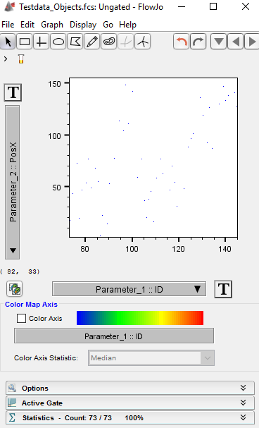

FlowJo window of the Testdata_Objects.fcs sample

1. Set the X-axis as Intensity Median Ch=5, and the Y-axis as Histogram. Click the “T” button and select Customise Axis from the drop-down menu.

□Explanatory note

Intensity Median Ch=5 is the intensity median of the saturation channel. In general, the median value is a more accurate reflection of the actual value as compared to the mean value as there may be some pixels with a high value, which may skew the actual mean value.

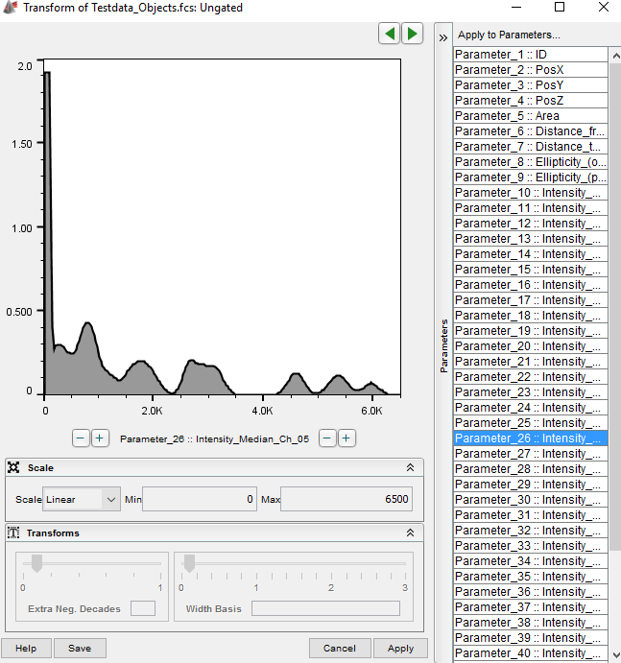

Setting display type and range of the axes scales in FlowJo

1. The Scale should be set as Linear, the Min value as 0, and the Max value as 6500. Click Apply.
2. Use the Range gating button (beside the arrow icon on the top left corner) to set the minimum and maximum limits of the gate as shown. You should now obtain a gate for the triple positive cells. Label the population as “White”.

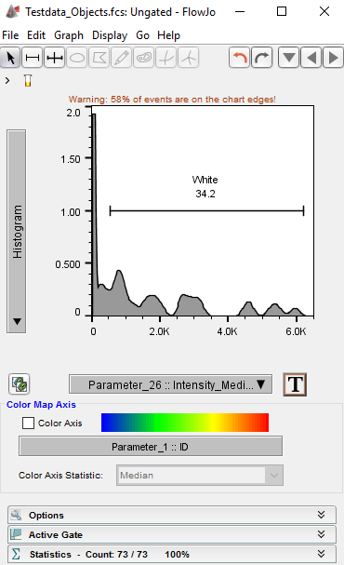

Histogram gating of the triple positive (‘White’) population

1. In order to identify the spatial localization of the gated cells, go to the workspace and double click on the White population.

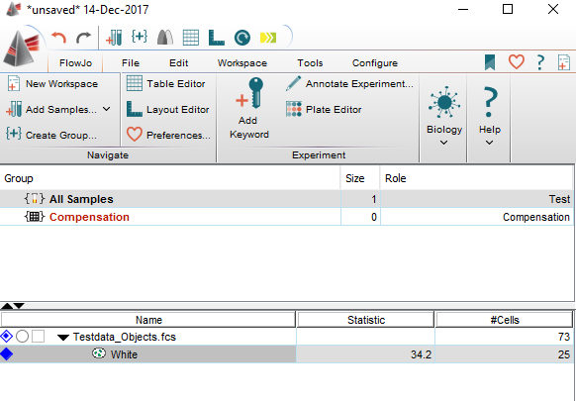

Selecting the ‘White’ population in the FlowJo workspace

The FlowJo window should open, set the X-axis as Pos X and the Y-axis as Pos Y. As there are very few surfaces, it is difficult to see the individual dots. To overcome this, click Display and select the option for Draw Large Dots.

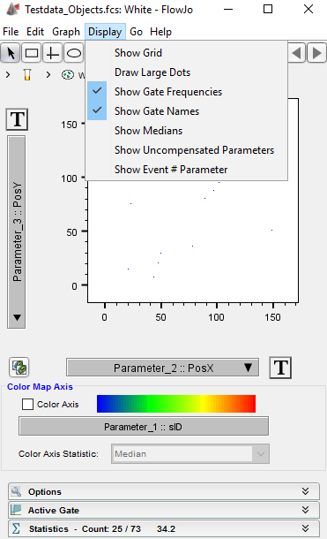

Selection of ‘Draw Large Dots’ option in FlowJo

1. To export the graph, right click the window and select Copy to Layout Editor. The Layout Editor should pop up. The following image should be obtained:

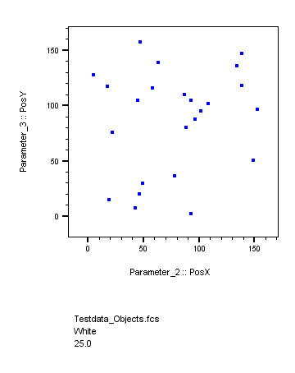

Exported spatial localization from Layout Editor in FlowJo

1. The population can now be exported for backgating. In the FlowJo workspace, right-click the White population and select Export/Concatenate Populations. The following window should pop up.

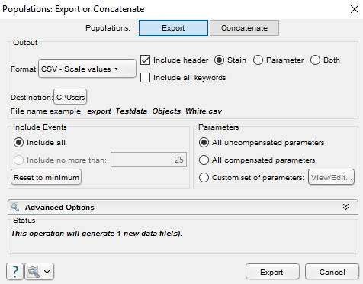

FlowJo export of populations

Use the settings as shown above. Take note that the Format used should be CSV-Scale values so that the ID of the surface objects are not modified by FlowJo. Set the Destination as C:\Users\Lenovo\Desktop\Data\Population. Click Export.

▲Critical step

Do not choose CSV-Channel values, as the numbers within each channel will be scaled by FlowJo and thus become changed. Theoretically, this scaling function should only happen when the export format of CSV-Scale values is chosen, but the scaling function has been swapped in this version of FlowJo. This is a bug that has yet to be rectified by the software manufacturer, but may be corrected in future versions.

### Backgating in Imaris (Version 8.4.2)

1. Open the Imaris file Testdata.ims in C:\Users\Lenovo\Desktop\Data\. Ensure that the mouse cursor has selected the surface (Surfaces 1) as shown below.

▲Critical step

If the correct surface is not selected, there will be an error message during the running of the script since the script is acting on the wrong object.

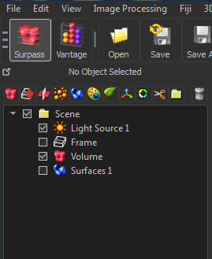

Backgating in Imaris Step 1

1. Go to Image Processing > XTIsolateSurfaceswithCsvList and start the script. The following dialog box will pop up.

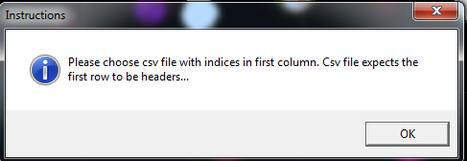

Backgating in Imaris Step 2

1. Click OK. Go to the filepath C:\Users\Lenovo\Desktop\Data\Population and select export_Testdata_Objects_White.csv, then click Open.
2. A new folder labelled Surfaces 1_subset should appear in the Surpass tree. Select the surface called Surfaces 1_Select which was created in this new folder. The color of the surfaces can then be changed by going to the Color tab, looking for the Color Type box, and selecting Base.
3. To check if triple positive cells have been correctly gated, set Channel 5 (saturation channel) as white using the similar procedure from **step 62** (Red: 1.000 Green: 1.000 Blue: 1.000). On the Display Adjustment tab, overlay Channel 5 together with the original three channels by checking Channels 1, 2, 3 and Channel 5 using the small check boxes beside the channel names. Set the following minimum and maximum values for Channel 5: Min: 0, Max: 4250.
4. To ensure that the signal from the original 3 channels can be viewed, uncheck Surfaces 1. The screen should show something similar to what is shown below. To turn the backgated surfaces on and off, check and uncheck Surfaces 1_Select.

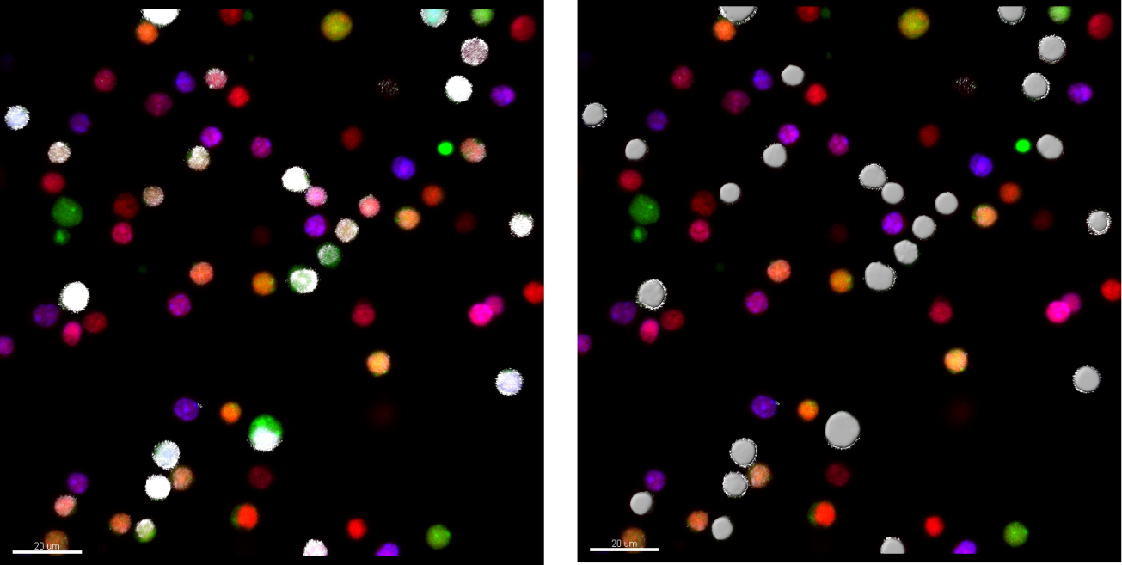

Backgated surfaces (right) compared to Saturation channel overlaid on the original 3 channels (left). These cells were originally very difficult to identify by eye alone.

▲Critical step

XTIsolateSurfaceswithCsvList works with Imaris 8.4, and as of the date of this tutorial creation, is not yet able to work with Imaris 9.0 or above. We were informed by the company representative that the developers are still working on getting Python scripts to work with surfaces in Imaris 9.0.

►Troubleshooting

If the population contains only 1 surface, the script will not be able to run. However, in this case, there should not be any point in running the script at all, but if absolutely required (e.g. for consistency), the user can perform a workaround by manually duplicating the surface of interest first.

►Troubleshooting

If an error occurs during the backgating, the user should double-check that the exported surface IDs from FlowJo match the original IDs of the surface. If the exported surface IDs from FlowJo are different, it could be due to a bug in FlowJo. You can try closing all the programs completely and repeating **Section 2.7** again.

# Spectral Compensation (optional)

## Compensation using FlowJo

In the case where there is spillover, spectral compensation is required. For the purposes of this tutorial, we will be using a test data set with a mixture of YFP- and GFP-containing mostly single-positive cells. Since we can unambiguously identify our single-positive cells using the data set itself, we do not need any ‘single stain’ controls for this example, but you may need to prepare them for your own dataset. You should acquire the ‘single stain’ controls on the same day with the exact same settings as your actual data.

1. Copy the folder called C:\Users\Lenovo\Desktop\Software\HSC\Data\Compensation\ to the filepath C:\Users\Lenovo\Desktop\Data\Compensation\.
2. Drag the file Compensation_Objects.csv from the C:\Users\Lenovo\Desktop\Data\Compensation\ folder into FlowJo. The program should automatically convert the CSV file into a FCS format.
3. Plot Parameter_6: Intensity_Center_Ch_01 (YFP) for the X-axis, and Parameter_7: Intensity_Center_Ch_02 (GFP) as the Y-axis. Click the T button for the X-axis. The scale should be set to Linear. Select Customise Axis… and set the minimum value as 50, maximum value as 2000. Do the same for the Y axis, but set the minimum value as 0, maximum value as 2500. See **Step 81-82** to recap if you have forgotten how to do this.
4. Select Display and click Draw Large Dots. Click on the Polygon gate button (four buttons away from the arrow icon on the top left corner) and gate the YFP+ and GFP+ cells as shown below:

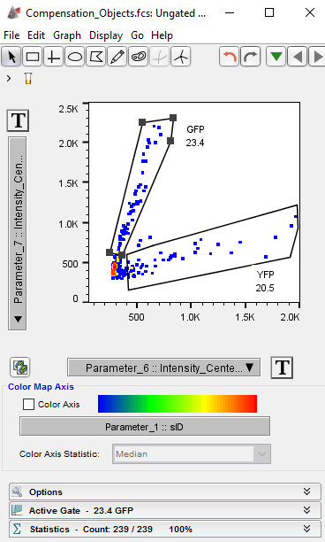

Individually gated populations

1. Create a new subfolder Compensation_Statistics under C:\Users\Lenovo\Desktop\Data\Compensation\. Go to the FlowJo workspace, select both the YFP and GFP populations and right click. Select Export/Concatenate Populations. Export both the populations as CSV-scale values in this folder. Click Export. The filenames that should appear are export_Compensation_Objects_YFP.csv and export_Compensation_Objects_GFP.csv.

►Troubleshooting

In older versions of FlowJo, you may need to export the two populations individually.

1. Run Microsoft Excel. Go to File > Open and point to the file export_Compensation_Objects_YFP.csv. Keep the FlowJo workspace open.

►Troubleshooting

Depending on your version of Microsoft Excel, you may need to open the file with a different procedure. Also, you may need to change the file type to the All files (*.*) option in order to see the CSV files in the folder.

1. Select **Column R** (Intensity_Center_Ch_01) (YFP) and **Column S** (Intensity_Center_Ch_02) (GFP), and press Ctrl + C to copy the columns. Create a new worksheet, select **Cell A1** (uppermost left corner), then press Ctrl + V to paste the data onto the new worksheet.

►Troubleshooting

Depending on your version of FlowJo, the exact columns for Intensity_Center_Ch_01 and _02 may not be the same. Adjust accordingly if this is the case.

1. Select **Columns A** and **B**. Click Insert > Scatter to plot Intensity_Center_Ch_02 (Y-axis) against Intensity_Center_Ch_01 (X-axis). Select the Scatter (without lines) type of graph as shown in the screenshot below.

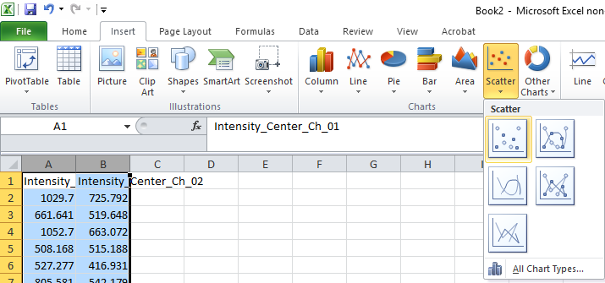

**Insert scatter plot without lines**

1. Left-click the graph to select the datapoints, right-click and select Add Trendline…. The Trendline Options window should pop up. Check the option box for Display Equation on chart.

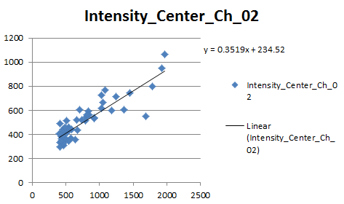

Calculating the coefficient for YFP spillover into GFP channel

Based on the gradient of this trendline, we can see that the percentage spillover from the YFP cells into the GFP channel is approximately 35.19%.

▲Critical step

Your aim is to calculate the slope as accurately as possible, and you should remove any outliers that you can spot. In our example above, the data point at (1684.39, 552.93) is clearly out of place, and when removed would modify the slope to 38.52%. For the sake of simplicity, we did not include this step in the tutorial, but you should be aware of this.

▲Critical step

Depending on the acquisition parameters and the excitation/emission dye spectra, note that there may not necessarily be any spillover. If the graph does not have an obvious correlation, or if you get a negative gradient, the true gradient is likely to be zero. You can turn on the Display R-squared value on chart option in the Trendline Options window to show the R2 statistic, which ranges from 0.0 to 1.0. A very low value indicates weak correlation, and may indicate no spillover in reality.

▲Critical step

To check for spillover from YFP cells into the GFP channel, it is critical that Intensity_Center_Ch_01 (YFP cells) is plotted as the X-axis, and that Intensity_Center_Ch_02 (detected spillover signal in GFP channel) is plotted as the Y-axis. Plotting the values in the wrong manner will lead to the wrong coefficients.

□Explanatory note

The calculation for the spillover coefficient is defined by the equation *y = mx + c,* where *y* represents the signal detected in the channel of interest and *x* is the signal from the original spilling channel. The spillover coefficient is the gradient *m*, which is the percentage of the signal from the original channel that has spilt into the detector of the other channel of interest. In this case, since the source cell population is YFP+, Channel 01 is the spilling channel, and thus always represents *x*. If you have more than 2 channels, you would modify this step to plot various channels as *y*, but always keep Channel 01 as *x* (e.g. Ch_02, Ch_03, Ch_04… vs Ch_01). Take note that the compound offset value *c* is inconsequential for subsequent linear algebra calculations, and only the slope *m* is critical.

□Explanatory note

We strongly recommend using the Intensity_Center_Ch_XX parameters for deriving the spillover coefficients, instead of other aggregate parameters such as intensity mean or median values. This parameter type refers to the channel intensities of the same pixel at the center of the surface, and thus most accurately reflect the spillover profile of the images on a per pixel basis.

1. Go to File > Open and point to the file export_Compensation_Objects_GFP.csv.
2. Select **Column R** (Intensity_Center_Ch_01) (YFP) and **Column S** (Intensity_Center_Ch_02) (GFP), and press Ctrl + C to copy the columns. Create a new worksheet, select **Cell A1** (uppermost left corner), then press Ctrl + V to paste the data onto the new worksheet.
3. Now, however, we need to ensure that Intensity_Center_Ch_02 (**GFP cells**) is recognized as the X-axis in this case, and Intensity_Center_Ch_01 (**detected spillover signal in YFP channel**) is recognized as the Y-axis. To do this, select **Column A** (YFP signal), press Ctrl + X to cut the column, then select **Column C**, and press Ctrl + V to paste.

□Explanatory note

By default, Microsoft Excel always recognizes the left-most column as the X-axis.

1. Plot Intensity_Center_Ch_01 (Y-axis) against Intensity_Center_Ch_02 (X-axis) in the manner described in **Steps 100** & **101**. This time, you should select **Columns B** and **C** in this case. A graph similar to what is shown below should be seen:

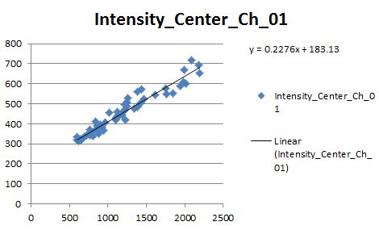

Calculating the coefficient for GFP spillover into YFP channel

The amount of GFP signal spillover to YFP is given by the gradient, which is the value 0.2276. In percentage terms, it is 22.76%.

1. In the FlowJo workspace, select Tools and Edit Compensation Matrix. The following window should pop up. Select the + button at the bottom left hand corner of the window and New Identity Matrix to add a new matrix. A window Choose Selected Parameters will pop up, select Parameter_6: Intensity_Center_Ch_01 and Parameter_7: Intensity_Center_Ch_02. Hold the Shift key to select multiple parameters. Click Choose Selected Parameters.

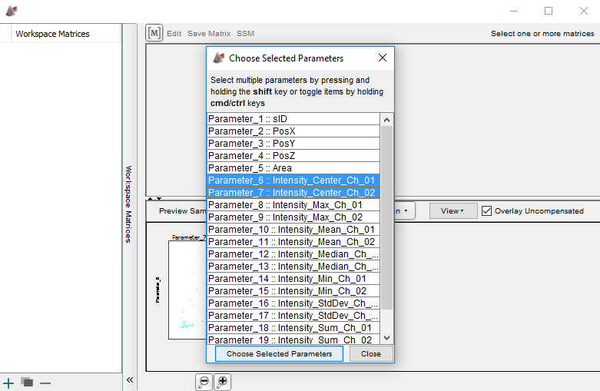

**Add new Compensation Matrix**

1. Key in the spillover coefficients into the compensation matrix in the format as shown below:

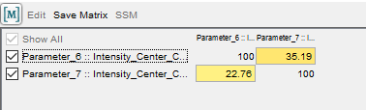

Compensation Matrix in FlowJo

□Explanatory note

The FlowJo Compensation Matrix is formatted in a manner where the **dyes** are represented by the **rows** and the **detectors** are represented by the **columns**. Hence, the spillover coefficient (35.19%) for YFP cells (Parameter_6, first row) into the GFP detector (Parameter_7, second column) is keyed in the first row, and vice versa for GFP cells (Parameter_7, second row) into the YFP detector (Parameter_6, first column). By definition, the amount of signal generated by YFP cells (first row) detected by the YFP detector (first column) is 100%, and the same holds true for GFP cells (second row) into the GFP detector (second column). The values in the diagonal are thus always fixed at 100.

1. Click the [M] button, hold, drag and drop it over the Compensation_Objects.fcs in the FlowJo workspace. A colored grid should now appear beside the Compensation_Objects.fcs file (indicated by the red arrow in the figure below). This indicates that the compensation matrix has been applied to the sample.

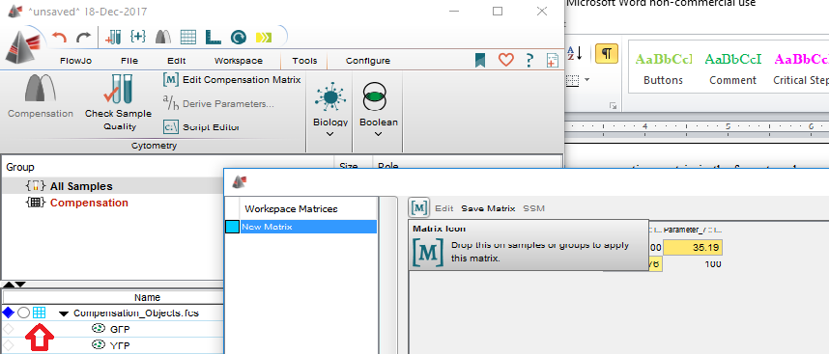

**Applying the compensation matrix to Compensation_Objects.fcs. When a compensation matrix has been applied successfully to a sample, a colored grid should show up beside it, as indicated by the red arrow here.**

1. In order to check that the GFP and YFP cells have been accurately corrected, go to the Compensation_Objects.fcs plot window, select Display > Show Uncompensated Parameters. Select the X-axis as Parameter_6: Intensity_Center_Ch_01 and the Y axis as Parameter_7: Intensity_Center_Ch_02. Right click and select Copy to Layout Editor. Next, select the X-axis as Comp-Parameter_6: Intensity_Center_Ch_01 and the Y axis as Comp-Parameter_7: Intensity_Center_Ch_02. Right click and select Copy to Layout Editor. An image like the one below should appear:

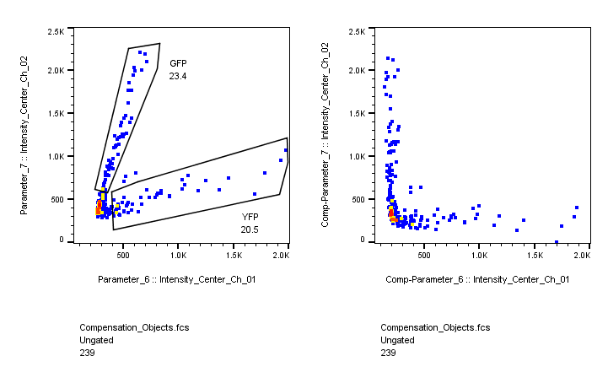

Comparison of dotplots of uncompensated and compensated channels

Note the perpendicular angle between the YFP and GFP dots, indicating a successful compensation.

If you do not need to correct the image, but just the histocytometry plots, then you can stop here. If the images themselves need to be corrected, then you should proceed with the steps in the next subsection.

## Correction of original images

1. Run the script S01_Channel unmixing.py. The following window should pop up:

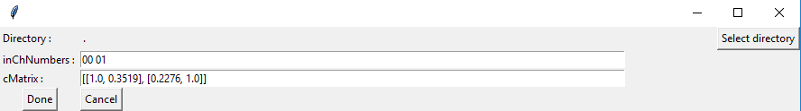

Graphical user interface of script S01

1. Key in the following values for the input channel numbers:

inChNumbers = 00 01

□Explanatory note

Any number of channels can be corrected by this script. In this case, channel “00” is YFP, channel “01” is GFP.

1. Key in the following values for the compensation matrix, then save and close Notepad:

cMatrix = [[1.0, 0.3519], [0.2276, 1.0]]

□Explanatory note

The matrix should be typed in the FlowJo format where the **row** headers are **Dyes**, **column** headers are **Detectors**. For this script, use ratios instead of percentages (e.g. use 1.0 instead of 100%).

1. Run the script, and point to the original uncorrected channels in C:\Users\Lenovo\Desktop\Data\Compensation\CompensationTIFF\ to generate the corrected channels in the subfolder S01_Unmixed.
2. Open C:\Users\Lenovo\Desktop\Data\Compensation\Compensation.ims with Imaris, which already has the surfaces of the cells. Ensure that Surfaces 1 is unchecked. To load in the corrected channels into the file, go to Edit, and select Add Channels…. Point to C:\Users\Lenovo\Desktop\Data\Compensation\CompensationTIFF\S01_Unmixed\ and click Open. Both the uncompensated and compensated channels will now be present. If the Display Adjustment tab is not open, click Ctrl + D. If the Display Adjustment tab is open, use the following settings to visualise the uncompensated and compensated channels using the following colours:

Channel 1 (uncompensated YFP) Min: 250 Max: 950 - red

Channel 2 (uncompensated GFP) Min: 250 Max: 1250 - green

Channel 3 (compensated YFP) Min: 210 Max: 910 -yellow

Channel 4 (compensated GFP) Min: 610 Max: 1610 -blue

Click Channel 3 in the Display Adjustment tab and under the Base Color tab, change the settings for Channel 3 and Channel 4 to:

Channel 3 Red: 1.000 Green: 1.000 Blue: 0.000 (yellow)

Channel 4 Red: 0.000 Green: 0.000 Blue: 1.000 (blue)

Toggle the various combinations of channels to see the effects of the channel unmixing on the original data.

You should be able to get the images illustrated below:



**Comparison of compensated and uncompensated channels.**

The GFP signal from the neutrophils that spilt into the YFP channel have been removed and the YFP signal from the dendritic cells that spilt into the GFP channel have been removed in the compensated channels. Now that the channels have been appropriately compensated, the user can then proceed with any downstream steps that they need to do for their own purposes.